Jaipur National University, Jaipur
Jagatpura, Jaipur

Online fitness center

Software Requirements Specification

Submitted By:

Members: (Bishal kr. Jaiswal & Hemant pd. Saini )

Under the supervision of

Team Guide :( Vishnu sharma)

SCHOOL OF COMPUTER AND SYSTEMS SCIENCES
JAIPUR NATIONAL UNIVERSITY, JAIPUR
Table of Contents

Description Page No.

1.0 Introduction 03-04
1.1 Purpose 3
1.2 Scope 3
1.3 Definition, Acronyms, and Abbreviations 4
1.4 References 4
1.5 Technologies to be used 4
1.6 Overview 5
2.0 Overall Description 05-09
2.1 Product Perspective
2.2 Software Interface
2.3 Hardware Interface
2.4 Product Function
2.5 User Characteristics
2.6 Constraints
2.7 Use Case Model Description
Class Diagram
Sequence Diagrams
2.8 Database Design
2.8.1 Schema & ER Diagram
2.9 Assumptions and Dependencies
3.0 Future Scope
Software Requirements Specification

1.0 Introduction:

We all know health is a wealth. We do not need a fancy car, big apartment, a doctor degree without a health. Being healthy is a first thing we need to keep in mind. Because most of time our attitude depends on how we feel. Being healthy and fit gives us energy to do anything. So how do we stay fit? Be active, eat green and hit a gym! Physical fitness is very necessary for a healthy and tension free life. Physical fitness includes diet, exercise and sleep. These three basic things have their own importance in each individual's life and everyone should be sensible with regard to these for a healthy life.

  - Purpose:

The purpose of Software Requirements Specification (SRS) document is to describe the external behavior of the Online Fitness center. Requirements Specification defines and describes the operations, interfaces, performance, and quality assurance requirements of the Online fitness center. The document also describes the non-functional requirements such as the user interfaces. It also describes the design constraints that are to be considered when the system is to be designed, and other factors necessary to provide a complete and comprehensive description of the requirements for the software. The Software Requirements Specification (SRS) captures the complete software requirements for the system, or a portion of the system. Requirements described in this document are derived from the Vision Document prepared for the Online Fitness center.

1.2 Scope:

The Software Requirements Specification captures all the requirements in a single document. The Online Fitness center that is to be developed provides the membership to get fit. He may have specific goals either to loss weight, gain weight, general maintenance or may be sport specific or even medical. We all have different bodies and each individual is different so sometimes it is beneficial to hire a personal trainer. The skilled guidance of the trainer keeps you involved in a variety of different fitness exercises so that you don't get astray. Fitness trainers are thorough professionals who know how to keep people motivated to follow the fitness programs. They plan the fitness program according to your individual needs. They will constantly keep you inspired and stimulated by keeping you involved in interesting activities. The Online Fitness center is supposed to have the following scope work .

- Determining the optimum floor size of the gym Identification, procurement & mapping of gym equipment.
- Determining the optimum equipment mix developing a system for allocation of equipments. Recruitment of staff.
- Training of gym staff on the latest international training modules in health and fitness.
- Fitness center will bring in latest development happening in the fitness industry globally by constant up gradation of knowledge and training to the benefits of the users.
- Fitness center will provide users of the gym with personalized training schedules.
- Fitness center will conduct fitness assessment of the users on quarterly basis and will provide them with goal driven fitness regime.

‘
  - Definitions, Acronyms, and Abbreviations:

- HTML (Hyper Text Markup Language): Hyper Text Markup Language, commonly referred to as HTML, is the standard markup language used to create web pages.
- JS (Java Script): JavaScript is the programming language of HTML and the Web. Programming makes computers do what you want them to do. This tutorial will teach you JavaScript from basic to advance.
- Sql (structure query language): It is used for database management system that provides a flexible and efficient database platform to raise a strong "on demand" business applications.
- Asp.net (Active x sever page):-It provide any language & design platform at the runtime for creating webpage.
- CSS (cascading style sheet):- Cascading Style Sheets (CSS) is a style sheet language used for describing the look and formatting of a document written in a markup language.

1.4 References:

1. Gold’s gym (www.goldgymindia.com)
2. The Bigapple (www.thebigapple.com)
3. Unique gym (www.uniquegym.com)
4. Monster gym (www.monstergymjaipur.com)

1.5 Technologies to be used:

- Js: (JavaScript)
- C#: Business Logic.
- Asp.net: Presentation Layer
- Sql: (Sql server management studio 2008 R2).
- Html:-Hyper text markup language.
- CSS:-Cascading Style Sheet.

1.6 Overview:

The SRS will include two sections, namely:

1. Overall Description:
Our proposed “online Fitness center” is for those who run a gym business. Before doing anything we did a decent research on major difficulties for gym owners. We examined carefully about how to make a huge registering system without failure as well as different functions for different kind of user depending on their privilege.

2. Specific Requirements:
First thing we wanted to do in designing is avoid boring formal user interface. So we tried to develop modern graphic user interface system. This application is for gym owners as well as for their staffs to register new member, and take body measurements and see the reports of financial and individual body progress. To use features of our application user has to enter password and username. If you want to visit and make changes in admin panel you have to unlock the admin panel by typing password in it. In the admin panel admin able to create username with password, set privilege to groups which means which user can do what operations like see report, take measurement etc. Also admin able to create groups and membership plans and apply it.

2.0 Overall Description:

2.1 Product Perspective: Corporate Fitness will begin by targeting small- to medium-sized businesses in the downtown Seattle area. The first task is to convince senior executives of the benefits and needs of wellness programs. This will be accomplished by aggressively pursuing interaction and relationships with business professionals who would profit from using this service. Once a strong image is established, Corporate Fitness will use similar strategies to market its services to larger corporations in Seattle and other areas of expansion.
Fitness is a health service that helps businesses and individual workers attain one of the greatest gifts of all--that of good health. Personal gains, such as improved self-esteem and self-motivation, combined with measurable benefits will create tremendous advantages for both the employer and the employee.

2.2 Software Interface:

1. Front End Client: Microsoft Visual Studio 2010
2. Web Server: Firefox, chrome, operamini, internet explorer etc.
3. Data Base Server: Sql server management studio 2008
4. Back End: Sql server management studio 2008

2.3 Hardware Interface:

1. Client Side: JavaScript, Html, Css.
2. Server Side: Microsoft visual studio 2010

2.4 Product Functions:

The main purpose of function is to define all activities or operations that take place in the system. These are derived through interactions with the users of the system. Since requirements specification is a comprehensive document and contains a lot of data, it has been broken down into different stages in this report.

Administrator module function:

Administrator has all the rights of maintaining all the records of Mobile Management. Administrators will be responsible for editing and updating the information of the application. Administrator will only have the rights to create users and give the permissions to the users.

Client module function:

A client has all the privileges on job seeker and the job seeker details. Client cannot make any changes in the new user creations.

2.5 User Characteristics:
- Automated membership management and payment processing
- Class scheduling that includes reservation management and attendance tracking
- Product management which allows owners to manage inventory and sell products online
- Schedule WODs (Workout Of the Day) and students can track their results
- Detailed financial reporting that provides insight into your business performance
- Book appointments for personal training and more
- Accept drop-in visitors
- Run campaigns and promotions
- Powerful automations, including reminders sent to students through e-mail and SMS about upcoming reservations
- Stay connected with students though detailed member profiles and communication features

2.6 Constraints:

- The information of all the users must be stored in a database that is accessible by the Online fitness center.
- The project information security system must be compatible with the Internet applications.
- The fitness center is connected to the server and is running all 24 hours a day.
- The users access all the categories from any computer that has Internet browsing capabilities and an Internet connection.
- The users must have their correct usernames and passwords to enter into the fitness center.

2.7 Use Case Model Description:

Class Diagram:

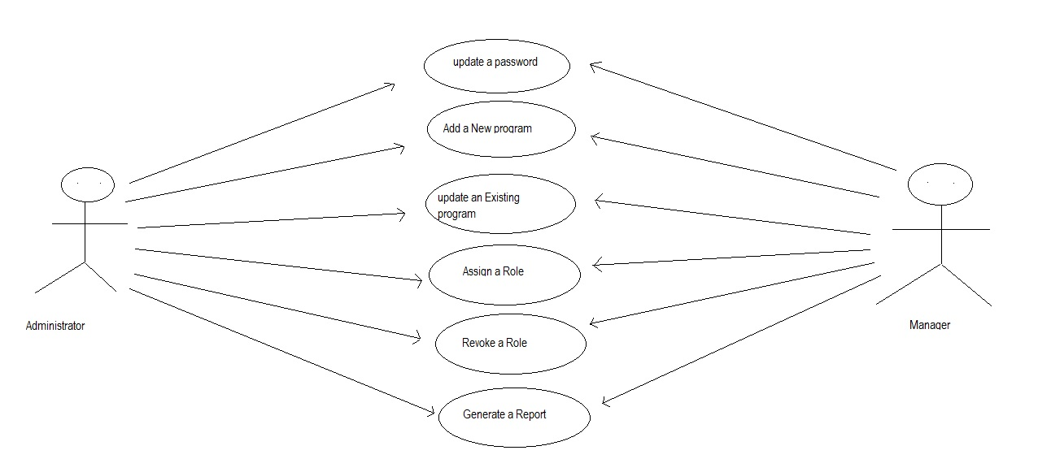

Sequence Diagrams:

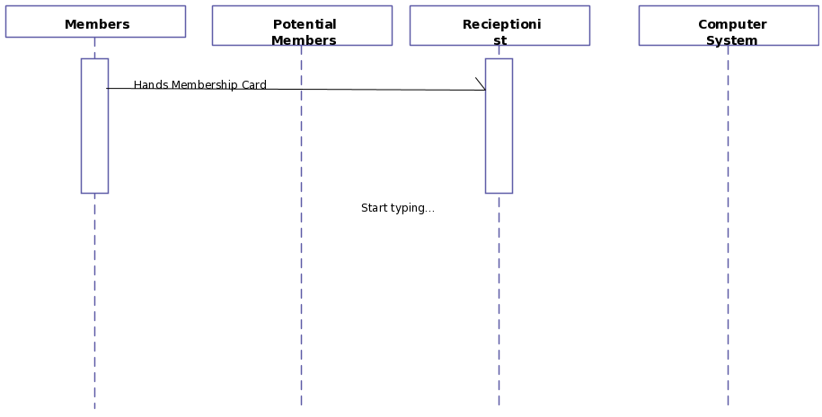

2.8 Database Design:

1)Login page

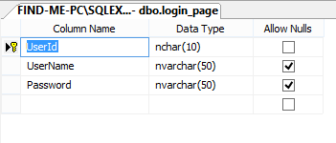
2)Register_page

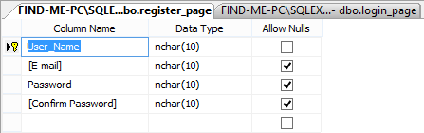
3)Change_password

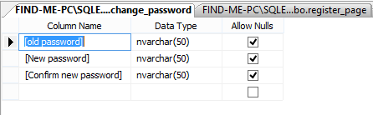

4) Payment_table

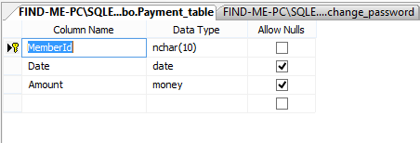

5)Fitness_details

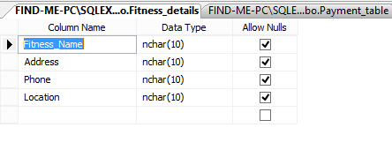
6)Member_table

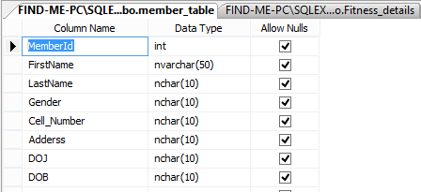

7)Workout_table

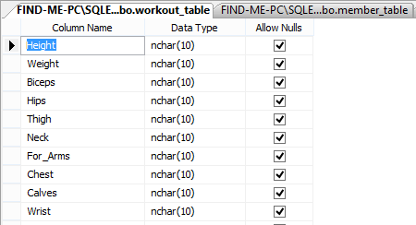

2.8.1 Schema & ER Diagram:

2.9 Assumptions and Dependencies:

- The users have sufficient knowledge of computers.
- The user’s computer should have Internet connection and Internet server capabilities.
- The users know the English language, as the user interface will be provided in English
- The product can access by the website database

3. Future Scope:

The project has been developed in a very short period of time and all efforts have been taken so that this project is very efficient in its execution there still exists some scope of improvement in our project. The following lists some of the enhancement that can be added incorporate into the project.
Application of the project can be done more attractively .Database management and stock maintenance module can be added which helps the administrator. This project can also be modified into a client server application. More security measures can be taken.

